PROJECT DOCUMENTATION

PROJECT TITLE: CONTACT MANAGER
TEAM ID: SWTID-2026-1193
TEAM LEADER:
- PRIYADHARSHINI R
Gmail: priyadharshini0510ravi@gmail.com

TEAM MEMBER’S:
- ANUPRIYA. S
Gmail: anupriyasargunan1007@gmail.com
- LEKHASHREE. V
Gmail: lekhashreelekhashree51@gmail.com
- THRISHA. P
Gmail: thrisha395@gmail.com

1. Project Overview
Purpose
ConnectHub is a backend-based contact management system designed to help users store, manage, and organize contact information efficiently. The application allows users to securely create accounts, log in, and manage their contacts through a structured API system.
Features
- User registration and login system
- Secure authentication using JWT
- Create, Read, Update, and Delete (CRUD) operations for contacts
- Tag-based contact categorization
- Real-time search functionality
- Backend API structure for integration with frontend applications

2. Architecture
The ConnectHub backend follows a three-tier architecture:
- Client Layer
The client layer interacts with the backend using HTTP requests. It can be a web or mobile application.
- Application Layer
The application layer is built using Node.js and Express.js. It handles API requests, authentication, business logic, and communication with the database.
- Database Layer
MongoDB is used to store user and contact data in a structured format. Mongoose is used as the Object Data Modeling (ODM) library.

3. Setup Instructions
Prerequisites
Before running the project, ensure the following software is installed:
- Node.js
- MongoDB
- npm (Node Package Manager)
- Git
- Code editor such as VS Code

Installation Steps
1️⃣ Install Node.js
After installation, verify:
node -v
npm -v
2️⃣ Create a Backend Project Folder
• Choose or create a directory where you want your backend.
• Create a new backend folder:
cd server
3️⃣ Initialize Node Project
Run: npm init -y
4️⃣ Install Dependencies
Install Express:
npm install express
npm install mongoose
npm install nodemon --save-dev

7️⃣ Start the Backend Server
Run: npm run dev
8️⃣ Open in Browser
Open: http://localhost:5000

4. Folder Structure
server/
│
├── controllers/
│ ├── authController.js
│ └── contactController.js
│
├── models/
│ ├── userModel.js
│ └── contactModel.js
│
├── routes/
│ ├── authRoutes.js
│ └── contactRoutes.js
│
├── middleware/
│ └── authMiddleware.js
│
├── config/
│ └── db.js
│
├── server.js
└── package.json

5. Running the Application
Start the development server using:
npm run dev
or
node server.js
After starting the server, open:
http://localhost:5000

The backend API will start running and can be accessed through API testing tools.

6. API Documentation
User Authentication
Register User
Endpoint:
POST /api/auth/register
Example Request:
{
"name":"priya",
"email": "priya@example.com",
"password": "123456"
}
Login User
Endpoint:
POST /api/auth/login
Example Request:
{
"email": "priya@example.com",
"password": "123456"
}

7. Authentication
Authentication in ConnectHub is implemented using JSON Web Tokens (JWT).
When a user logs in successfully, the server generates a token that is used to access protected routes.

This token must be included in the request header when accessing protected API endpoints.

8. User Interface
The system can be integrated with a frontend dashboard that allows users to interact with the backend.
Main UI components include:
- Login and Registration pages
- Contact list dashboard
- Add contact form
- Edit contact form
- Search bar for filtering contacts
The interface communicates with backend APIs to display and update data dynamically.

9. Testing
The backend APIs can be tested using tools such as:
- Thunder Client (VS Code Extension)

10. Future Enhancements
Future versions of the system can include advanced features to improve functionality and user experience.

11.OUTPUT SCREENSHOTS
1.Register api:
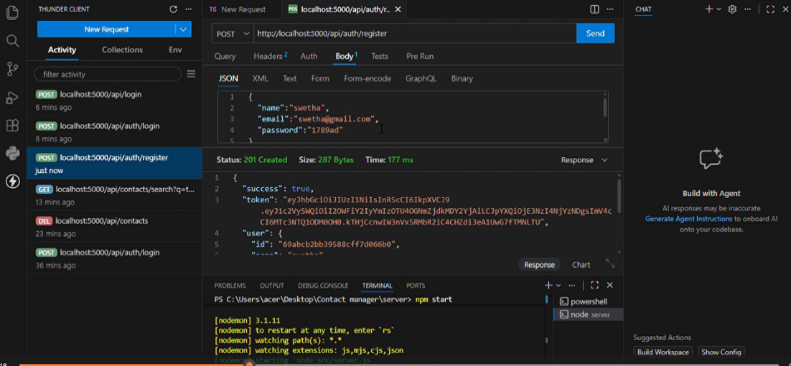

2.Login api:
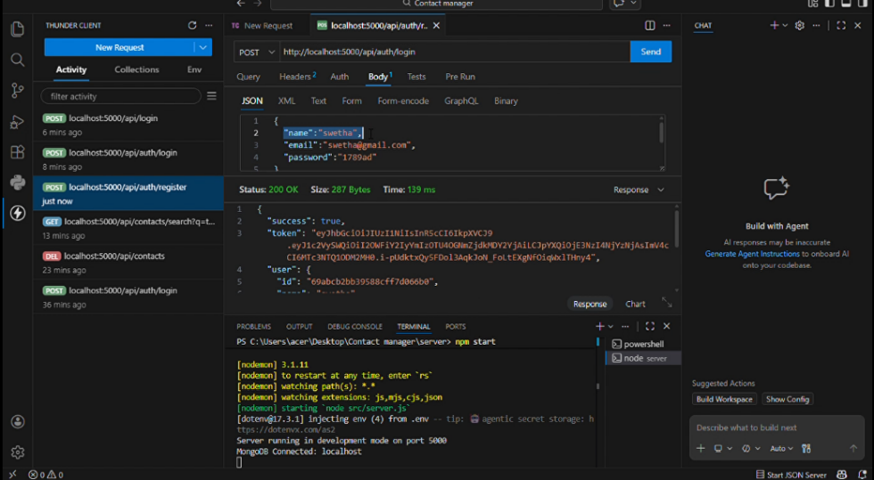

3.Add new contact:
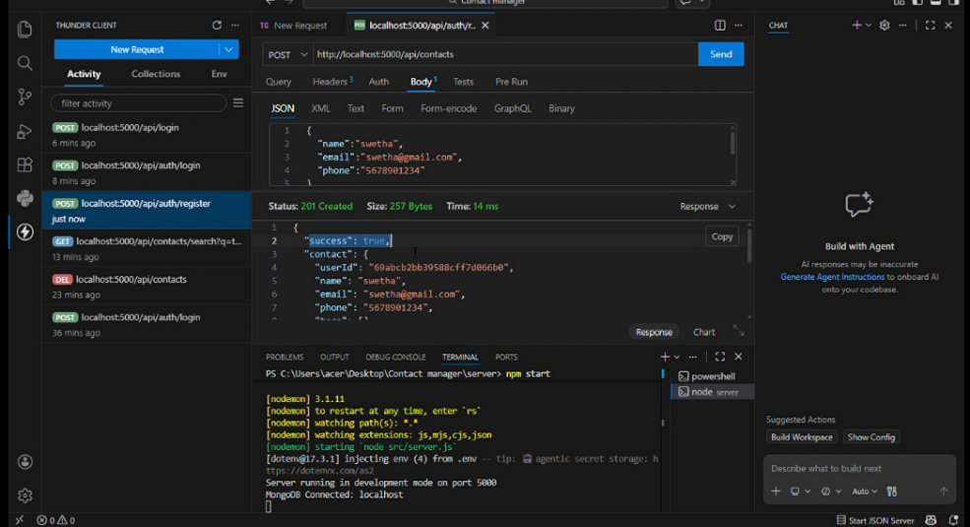

4.Update contact:
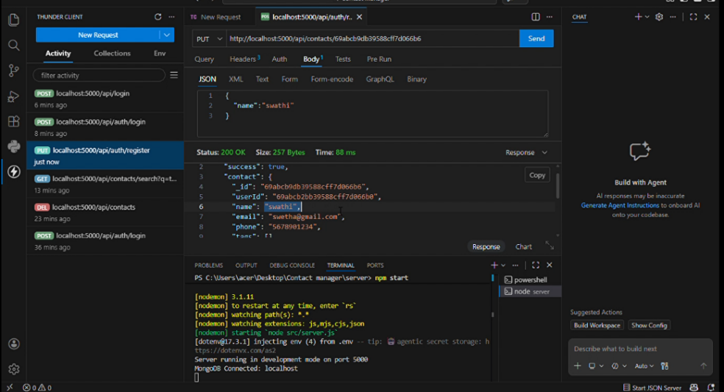
5.Delete contact:
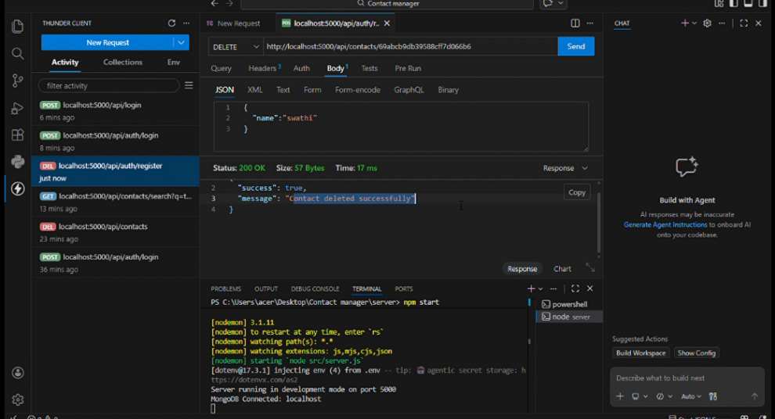

6.Search contact:
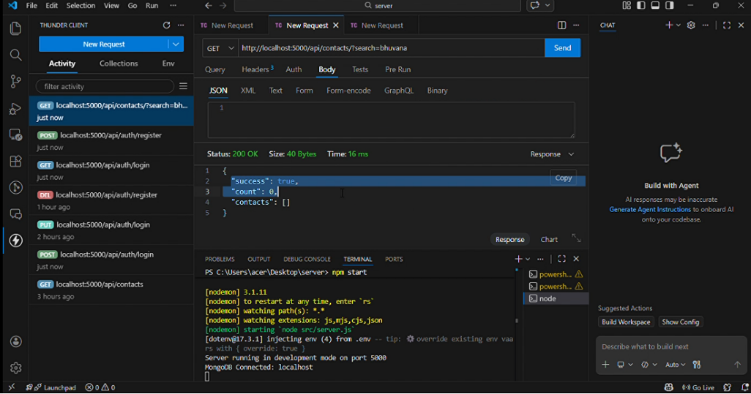

7.Get the current user:
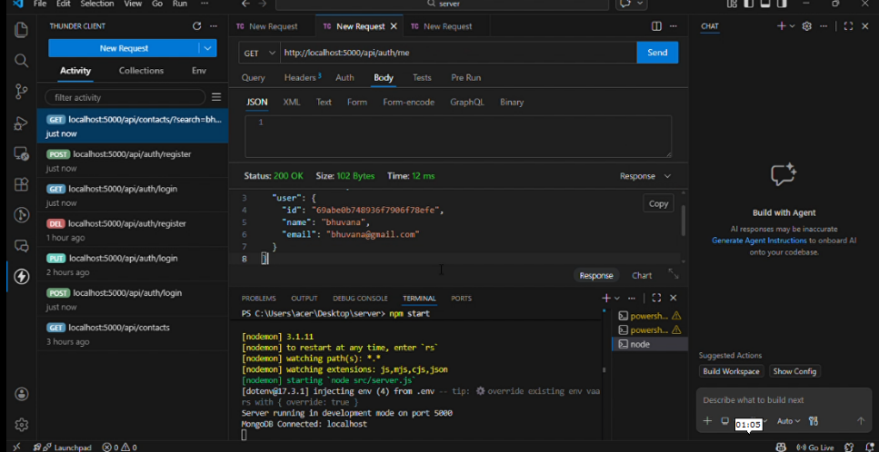

Project Demo :
https://drive.google.com/file/d/1zrj5GFPW3qMgeHQz7WKkil-MhCZhUbo6/view?usp=drive_link

